**1. VL with Quadratic: data length, Regression Error, Non-self match threshold,k, alpha, anomalies, time**

(0-5000), 6, 1, 2,2,(2624-2681)(1348-1410)(2761-2837),00:00:08

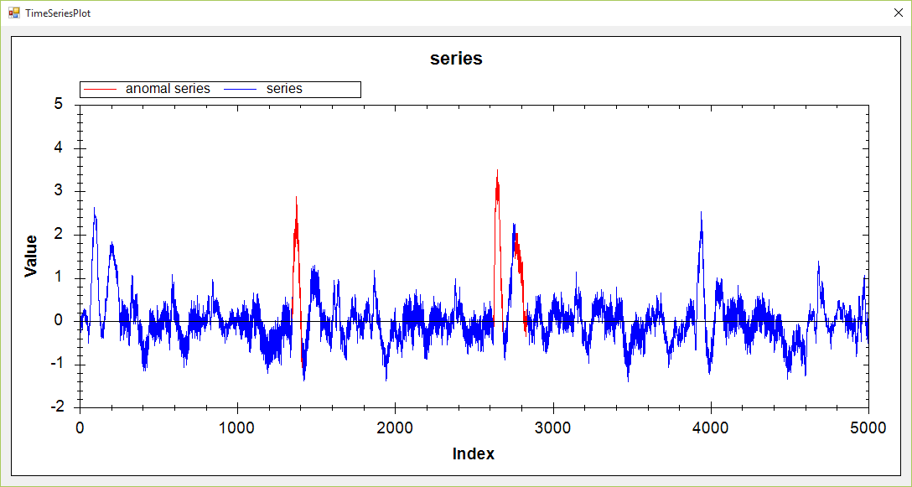

(0-5000), 5, 1.5, 1,3,(2628-2682)(1348-1407),00:00:08

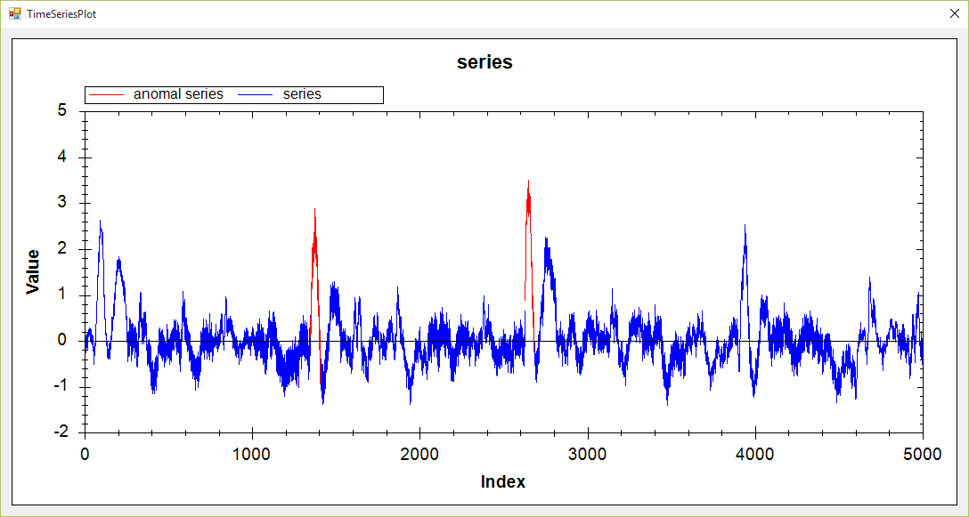

(0-5000), 8, 1.0, 1,2,(2613-2833),00:00:08

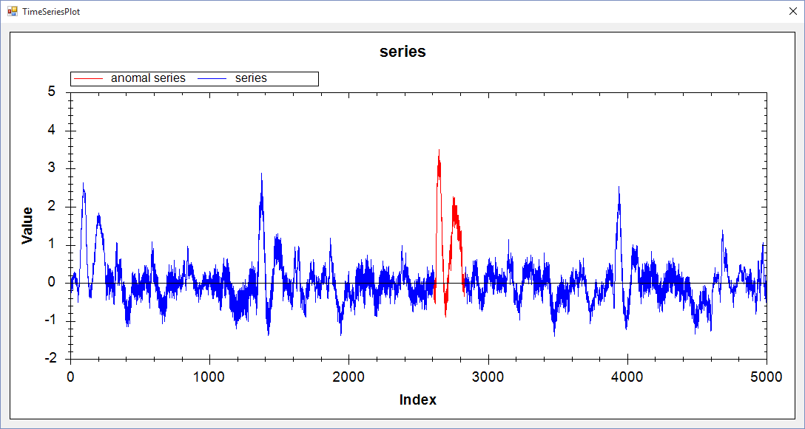

(0-5000), 3.5, 1.0, 1,2,(2623-2674),00:00:13

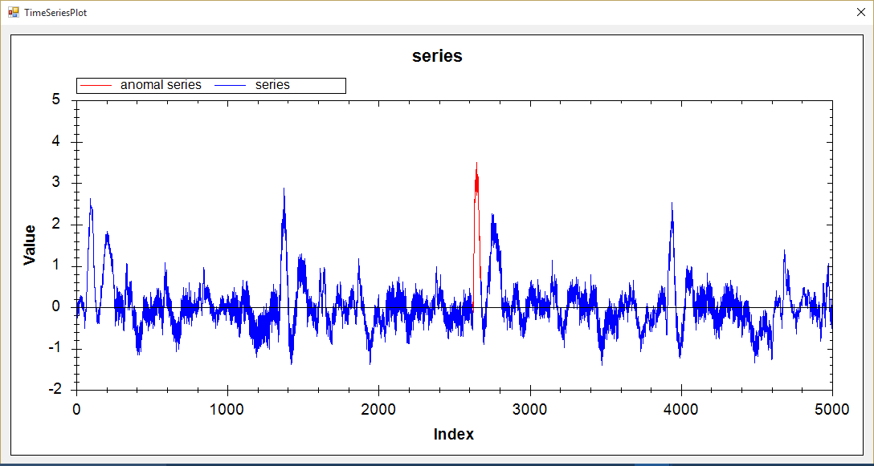

**2. VL with Extrem Points: : data length, R, Min-length,k, alpha, anomalies, time**

(0-5000), 1.5, 10,1, 3, (2649-2751)00:00:33

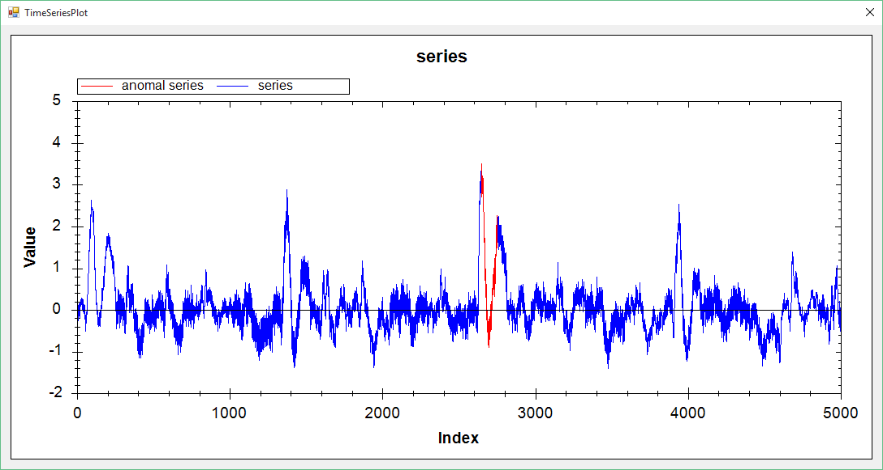

(0-5000), 1.5, 10,1, 1.8, (2621-2918)(75-322)(1373-1488),00:00:31

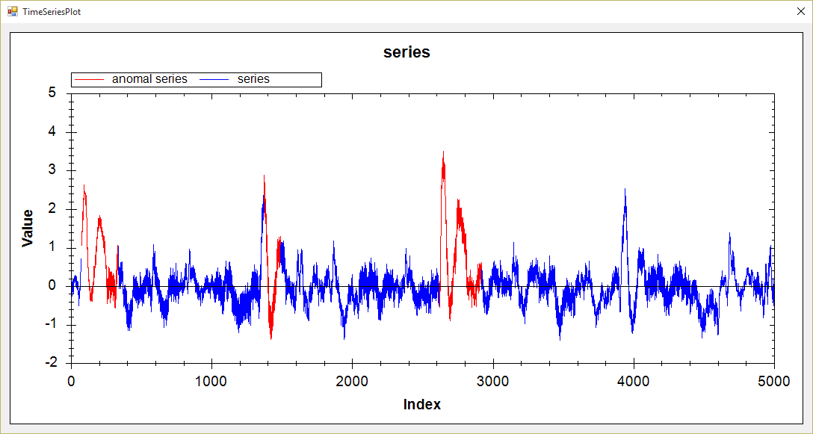

(0-5000), 1.45, 10,1, 2.0, (2602-2918)(75-268)(1373-1488),00:00:52

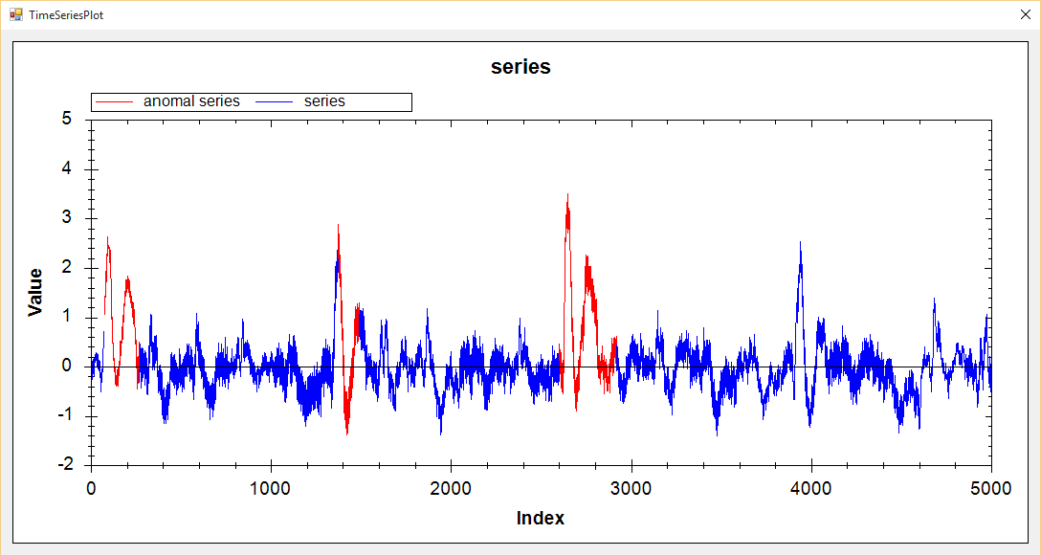

**3. Hot Sax: data length, subsequence length, paa length,begin length, time**

(0-5000), 60,6, 2626, 00:01:00

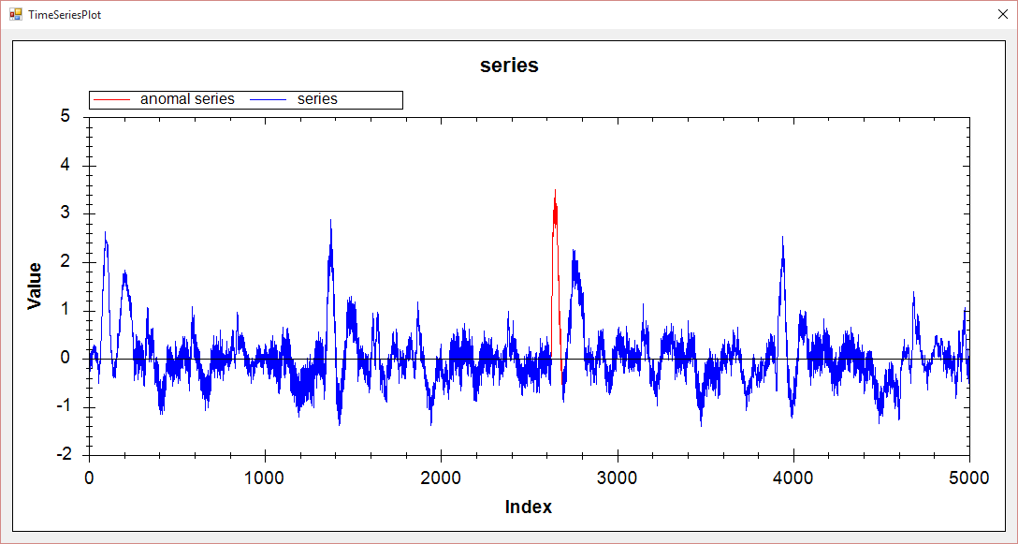

(0-5000), 128,10, 2543, 00:01:05

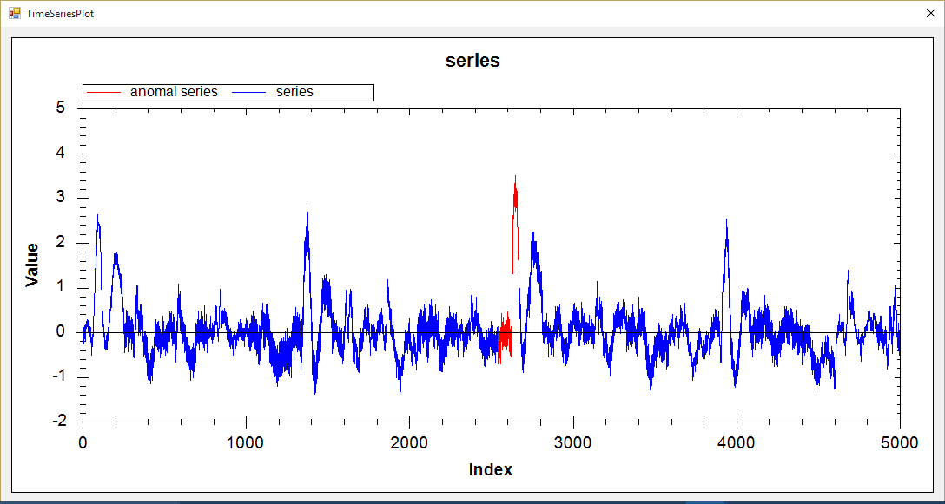

(0-5000), 300,30, 2518, 00:00:55

